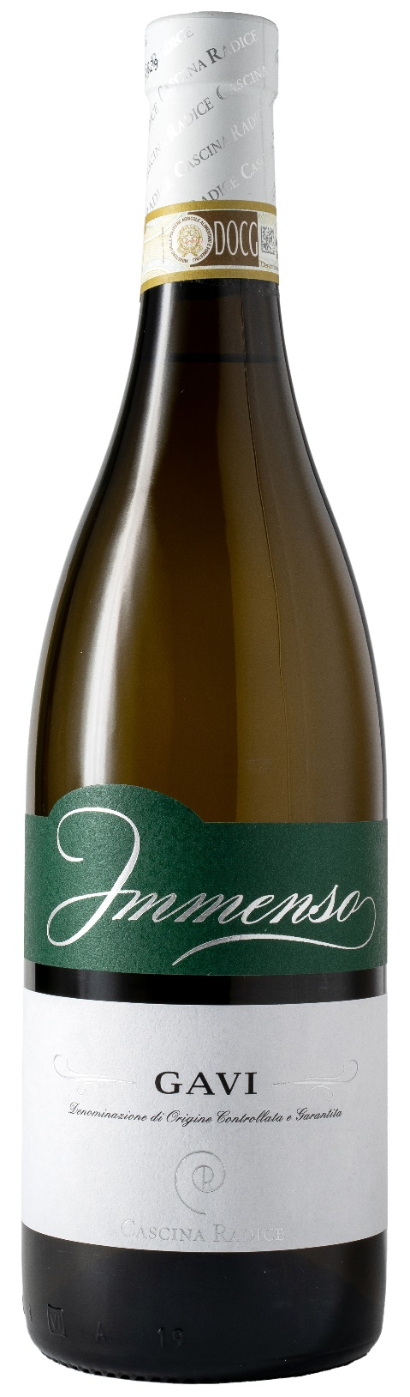
GAVI DOCG – IMMENSO

Grape: Cortese 100%
Alc. Vol.%: 12,5
Vintage: 2025
Residual sugar g/l: 1,0
Total acidity g/l: 5,5
Region: Piedmont
Production zone: Vineyards in the area of Gavi (Alessandria)
Capacity: 750ml

CHARACTERISTICS

Vinification: In steel tanks at a controlled temperature
Aging: In steel tanks until bottling
Yield per ha: 8000kg
Colour: Straw yellow with greenish sparkles
Bouquet: Delicate, floral and slightly mineral
Flavour: Dry, subtle, harmonious and fresh

SERVING SUGGESTIONS

Best enjoyed with fish, seafood and delicate soups.
Serving temperature 10 °C
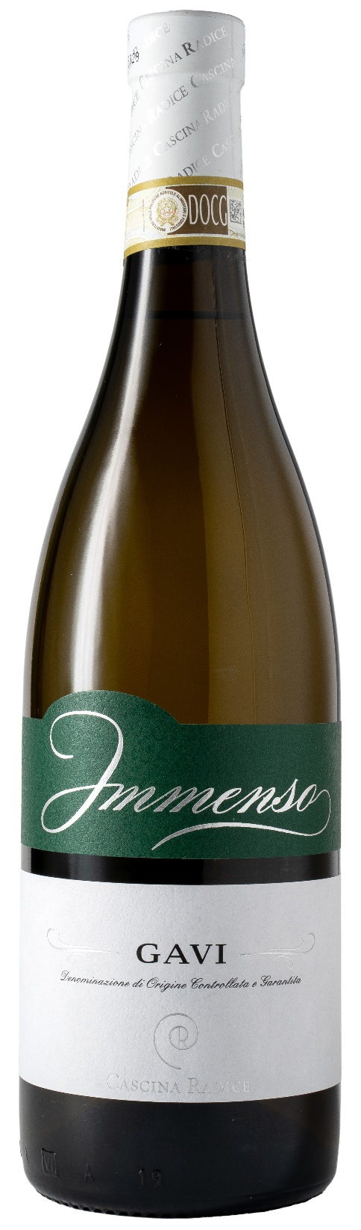
TECHNICAL INFORMATION / PALLETIZING

Size 750ml:
Article Nr. V02016A
GTIN-13 bottle 8017868000556
GTIN-13 carton 8017868000631
Closure Cork
Bottles / carton 6 bottles
Pallet size 80x120cm
Cartons/layer 21
Cartons/pallet 105
Kg/carton 8,1
Kg/pallet 870

Contains sulphites
GMO Free
Revisione 01. 21.04.2026

